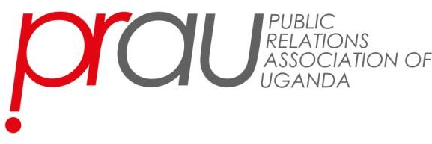

CONSENT FORM
Purpose
This consent form outlines the agreement between the PR agency (hereinafter referred to as "Agency") and the Public Relations Association of Uganda (PRAU) regarding the submission of award entries on behalf of other PR organisations (hereinafter referred to as "Client Organizations") for the PRAU Excellence Awards 2026.

Agreement Details
- Authorised Representation: The Agency confirms that it has the authority to represent and submit award entries on behalf of the Client Organisations listed below.
- Client Perspective: All award entries submitted by the Agency on behalf of Client Organisations will be written and branded from the client's perspective.
- Intellectual Property: The Agency warrants that it has sought and obtained permission to use the intellectual property (brand names, logos, etc.) of the Client Organisations for the purpose of award submissions.
- Confidentiality: The Agency agrees to maintain the confidentiality of all award submissions and related materials.
- Compliance: The Agency will comply with all rules and guidelines set forth by PRAU for the Excellence Awards.

Client Organisations Represented
Please provide the names and details of the Client Organizations you are representing:

- Client Organization Name: [Insert Client Organization Name]
  - Contact Person: [Name]
-Signature of Client:
  - Email: [Email Address]
  - Phone: [Phone Number]

- [Repeat for additional Client Organizations]

Signature
By signing below, the Agency acknowledges and agrees to the terms outlined in this consent form.

Agency Representative's Full Name: Signature:
Date:

Plot 35, Ntinda Road, Ground Floor, GF 19
P.O. Box 3206, Kampala Uganda
Tel: +256 414 343171,
Email: prauganda@gmail.com

